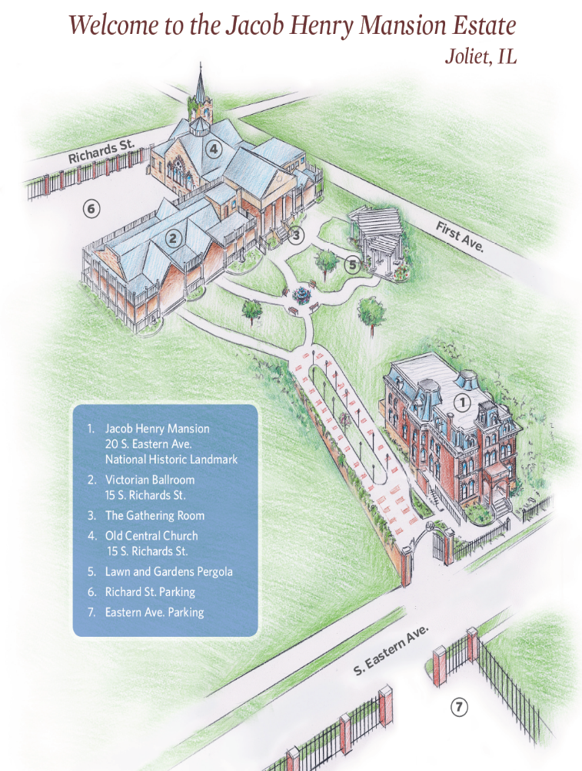
**One Way**
Please park in the Church parking lot (#6) on Richards St.
Extra parking: Mansion lot on Eastern Ave. (#7) and on First Ave.
Venue location: Old Central Church (#4)
Cocktail hour: Gathering Room (#3)
Reception: Victorian Ballroom (#2)
**One Way**
Please park in the Church parking lot (#6) on Richards St.
Extra parking: Mansion lot on Eastern Ave. (#7) and on First Ave.
Venue location: Old Central Church (#4)
Cocktail hour: Gathering Room (#3)
Reception: Victorian Ballroom (#2)

